8. Implement in aggregation function (e.g. sum, count, avg) on database record run on mysql workbench.

Create a Table

create table employees7(
emp_id int primary key auto_increment,
emp_name varchar(50),
department varchar(30),
salary decimal(10,2)
);
desc employees7;

Insert some sample data

insert into employees7(emp_name,department,salary) values
('gauri','it',40000),
('babli','it',55000),
('shravni','hr',42000),
('pari','finance',40000),
('ravi','finance',35000),
('bhavi','hr',28000);
select*from employees7;

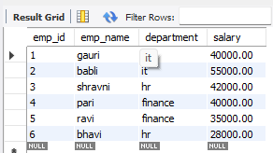

SUM() Total salary per department

select department, sum(salary)as department_salary
from employees7
group by department;

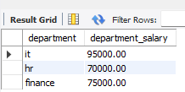

COUNT()employees in each department

select department, count(*)as total_employees7
from employees7
group by department;

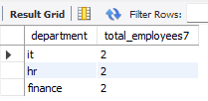

AVG()Average salary per department

select department,avg(salary)as avg_salary
from employees7
group by department;

